Angela Boardman

Nabeel Qazi

Katie Manzoline

Presentation Summary – Team Booth

We have examined global mortality and life expectancy data and global economic data to look for correlations among mortality rates, GDP (Gross Domestic Product), and life expectancy by country and by region.

Our hypothesis is that life expectancy is positively correlated with GDP. As GDP increases, life expectancy will also increase. Our hypothesis also concludes that mortality rate is inversely related to GDP. As GDP increases, mortality will decrease.

The null hypothesis is that neither life expectancy or mortality rate are affected by GDP.

Is life expectancy really increasing over time?

We wanted to first see that life expectancy was actually increasing throughout the world before comparing it to GDP. We plotted mean life expectancy of all countries from 2000-2015 on a line graph to show that yes, life expectancy is increasing over time.



Does life expectancy increase as a countries GDP increases?

There were a few ways we looked into this question. First, we took the mean life expectancy and plotted this against the mean GDP from 2000-2015. This did show a positive correlation. But since these were averages of the whole world, we also plotted life expectancy versus GDP for just the year 2000. After calculating the linear regression, we found the r squared value to be .31. This is a low correlation. Life expectancy only somewhat increases due to GDP.

 

How does GDP increase over time?

We wanted to see how GDP was actually increasing throughout the world before comparing it to life expectancy and mortality. We plotted mean GDP of all countries from 1970-2018 on a line graph to show that yes, GDP is increasing over time. We mapped out GDP by country for any given year (below image is for 2018) to show which countries have higher GDP than others. This map also helps illustrate which regions have more/less GDP than others.

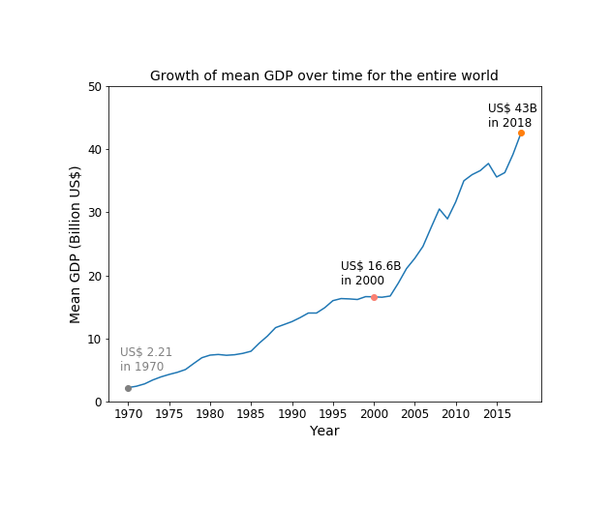



Does mortality decrease as GDP rises?

We plotted out average mortality rates versus average GDP on a scatter plot for 2000-2016. This illustration appears to show us that generally, as GDP rises, mortality rates decrease. However, because of outlying values skewing the GDP high, this plot is displaying mortality rates for only those GDP values within a range that is equidistant from the median GDP.



Does mortality affect certain regions of the world more than others?

As we did with GDP, we wanted to see if certain regions were more affected by morality rates than others. We placed these rates on a heat map and also a bar graph to help illustrate any differences. Based off of this research, these show that Africa is the region with the highest mortality rates.

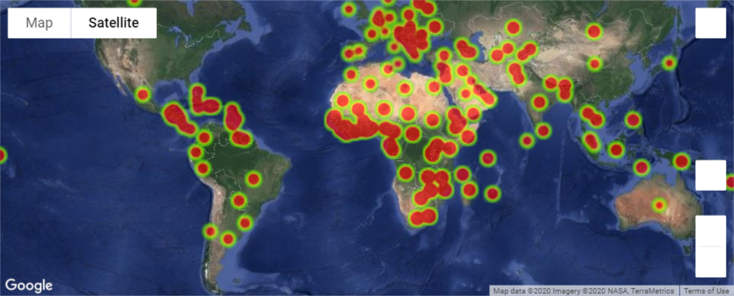

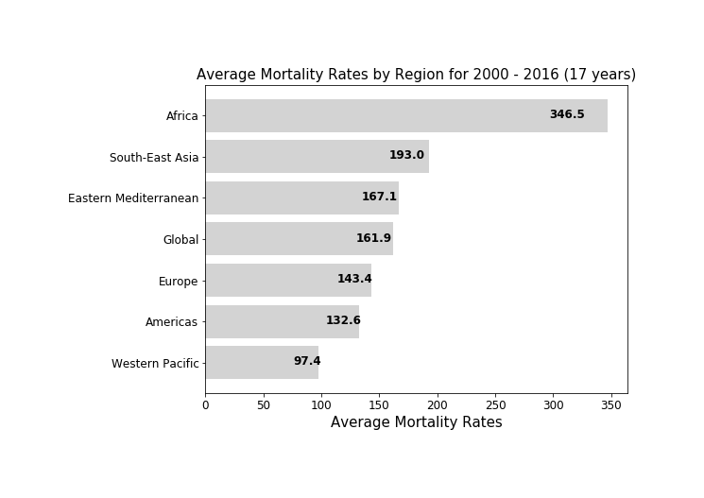

Overall, our findings do show that as GDP rises, life expectancy rises and mortality rates drop. We can reject our null hypothesis.

Data Sources

Google public data repository. [Centroid data by country.] Downloaded from: <https://developers.google.com/public-data/docs/canonical/countries_csv>

Kaggle. WHO Life Expectancy Data. Retrieved from:

<https://www.kaggle.com/kumarajarshi/life-expectancy-who/version/1>

World Bank. GDP data for the last 50 year.

World Health Organization Global Health Observatory data repository. "Adult mortality data by country." Retrieved from:

<http://apps.who.int/gho/data/view.main.1360?lang=en¶>